Cartel

A cartel is a group of independent market participants who collude with each other in order to **improve their profits and dominate the market**. A cartel is an organization formed by producers to limit competition and increase prices by creating artificial shortages through low production quotas, stockpiling, and marketing quotas. Cartels can be vertical or horizontal but are inherently unstable due to the temptation to defect and falling prices for all members.

Additionally, advancements in technology or the emergence of substitutes may undermine cartel pricing power, leading to the breakdown of the cooperation needed to sustain the cartel. Cartels are usually associations in the same sphere of business, and thus an alliance of rivals. Most jurisdictions consider it anti-competitive behavior and have outlawed such practices. Cartel behavior includes **price fixing**, **bid rigging**, and **reductions in output**. The doctrine in economics that analyzes cartels is cartel theory. Cartels are distinguished from other forms of collusion or anti-competitive organization such as corporate mergers.

# History of cartels

Cartels have existed since ancient times. Guilds in the European Middle Ages, associations of craftsmen or merchants of the same trade, have been regarded as cartel-like. Tightly organized sales cartels existed in the mining industry of the late Middle Ages, like the 1301 salt syndicate in France and Naples, or the Alaun cartel of 1470 between the Papal State and Naples. Both unions had common sales organizations for overall production called the *Societas Communis Vendicionis* ('Common Sales Society').

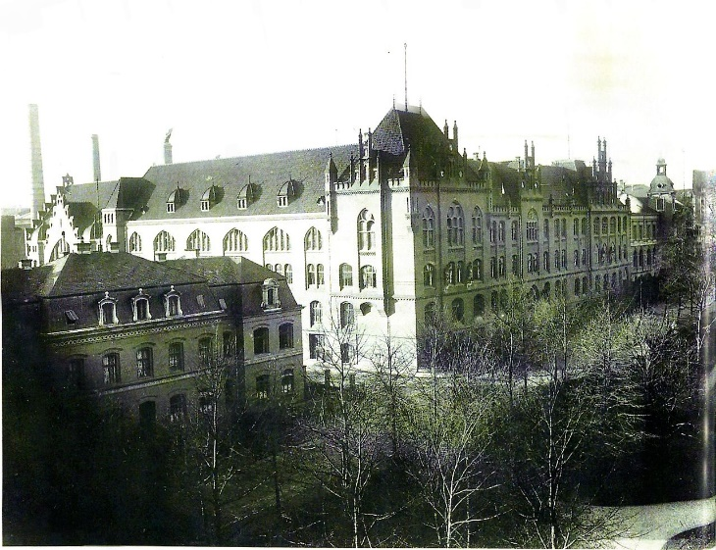

Laissez-faire (liberal) economic conditions dominated Europe and North America in the 18th and 19th centuries. Around 1870, cartels first appeared in industries formerly under free-market conditions. Although cartels existed in all economically developed countries, the core area of cartel activities was in central Europe. The German Empire and Austria-Hungary were nicknamed the "lands of the cartels". Cartels were also widespread in the United States during the period of robber barons and industrial trusts.

# Effects of cartel

A survey of hundreds of published economic studies and legal decisions of antitrust authorities found that the median price increase achieved by cartels in the last 200 years is about 23 percent. Private international cartels (those with participants from two or more nations) had an average price increase of 28 percent, whereas domestic cartels averaged 18 percent. Less than 10 percent of all cartels in the sample failed to raise market prices.

In general, cartel agreements are economically unstable in that there is an incentive for members to cheat by selling at below the cartel's agreed price or selling more than the cartel's production quotas. Many cartels that attempt to set product prices are unsuccessful in the long term because of cheating punishment mechanisms such as price wars or financial punishment. An empirical study of 20th-century cartels determined that the mean duration of discovered cartels is from 5 to 8 years and overcharged by approximately 32%. This distribution was found to be bimodal, with many cartels breaking up quickly (less than a year), many others lasting between five and ten years, and still some that lasted decades. Within the industries that have operating cartels, the median number of cartel members is 8. Once a cartel is broken, the incentives to form a new cartel return, and the cartel may be re-formed. Publicly known cartels that do not follow this business cycle include, by some accounts, OPEC.

Cartels often practice price fixing internationally. When the agreement to control prices is sanctioned by a multilateral treaty or protected by national sovereignty, no antitrust actions may be initiated. OPEC countries partially control the price of oil.